Comparative Analysis of Old Dominion University with Peer Institutions in Graduate Metrics

The data for this analysis comes from the Survey of Graduate Students and Postdoctorates in Science and Engineering (GSS) [1], an annual census providing comprehensive data on graduate and postdoctoral education in the United States. Sponsored by the National Center for Science and Engineering Statistics within the National Science Foundation and by the National Institutes of Health, the survey collects data from all U.S. academic institutions offering research-based master’s and doctoral programs in science, engineering and selected health fields as of the fall of the survey year. This data collection is crucial for tracking trends in STEM education and the science and engineering workforce.

The GSS captures detailed information on the total number of master’s and doctoral students, postdoctoral appointees, and doctorate-level nonfaculty researchers. It categorizes data by field of study or research, demographic characteristics, and other relevant factors, such as the primary sources of financial support. This enables an analysis of trends in graduate education and postdoctoral research across disciplines, supporting insights into workforce development and funding allocation patterns.

# Overall Assessment for ODU

The analysis compares graduate education metrics of Old Dominion University (ODU) with a cohort of similar institutions, using data for Earned Doctorates, Graduate Students, Source of Support, and Postdoctorates. ODU’s trends are highlighted in **Monarch Blue** for clarity.

**Earned Doctorates in Science, Engineering and Health**:

ODU exhibits a stable trajectory in the number of earned doctorates awarded over the years, with values generally between 100 and 150, indicating consistent productivity in doctoral completions. In comparison, some institutions, such as George Mason University and Temple University, demonstrate higher variability and, at times, surpass ODU with earned doctorates peaking above 250. This pattern suggests that while ODU maintains steady output, other universities experience fluctuations that may be tied to larger graduate programs or more variable research funding. A graph showing different colored lines

**Graduate Students in Science, Engineering and Health**:

ODU’s graduate student population remains relatively stable, hovering around 2,000 students, aligning with other institutions in the lower to mid-range of the spectrum. Notably, universities like Northeastern University and George Mason University have much higher counts, with Northeastern exceeding 8,000 students in recent years. This contrast indicates that while ODU sustains a moderate and stable graduate enrollment, certain institutions are experiencing significant growth in their graduate programs, potentially due to expanded online offerings or specialized programs that attract larger student cohorts. A graph of a graph of a graph of a graph of a graph of a graph of a graph of a graph of a graph of a graph of a graph of a graph of a graph of
**Postdoctorates in Science, Engineering and Health**:

ODU maintains a modest presence in terms of postdoctoral appointments, with fewer than 50 over the observed period. This is relatively low compared to institutions like Notre Dame University and George Mason University, where postdoctoral counts frequently exceed 150. ODU's limited postdoctoral population may reflect its programmatic focus, suggesting that it may prioritize doctoral completions over cultivating postdoctoral research opportunities. This distinction positions ODU within a cohort of institutions focused more on teaching and doctoral completions than large-scale postdoctoral research expansion.

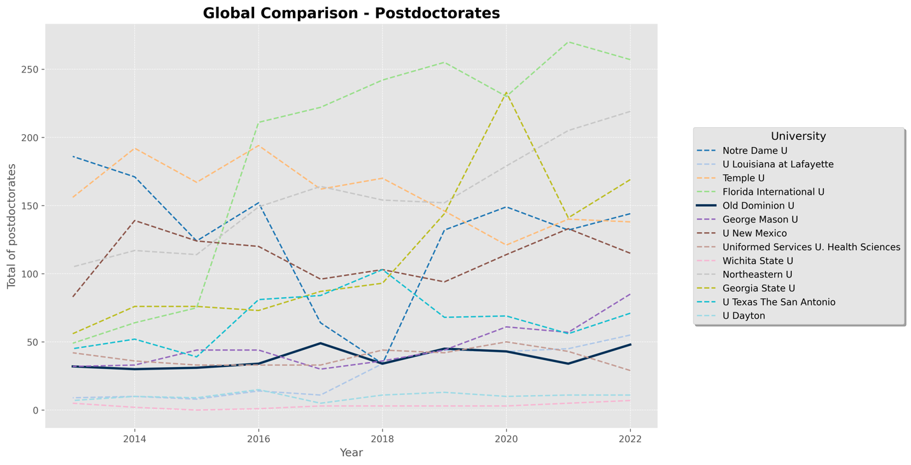**Source of Support for Graduate Students in Science, Engineering and Health**:

Funding sources for full-time graduate students at ODU reflect a steady but moderate level of federally supported students relative to institutions like Northeastern University, which shows a marked increase over time. ODU’s consistent funding levels, in contrast to Northeastern’s rapid growth, could indicate differences in research grant acquisition, the scope of federally funded projects, or institutional focus on graduate assistantships. This stability in federal support at ODU may reflect a balanced funding model but also suggests potential for growth in securing federal research funding.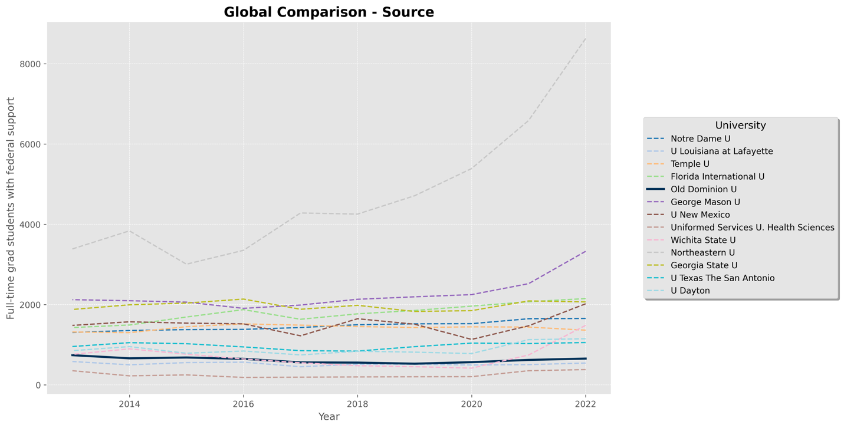

In Summary, ODU’s metrics across these categories reflect a stable, mid-sized research institution with a consistent doctoral output and moderate graduate enrollment. In comparison, other institutions display more significant variability and, in some cases, significantly more extensive scale in graduate and postdoctoral populations. ODU’s stable trajectory in federal support and graduate enrollment suggests a balanced growth and resource allocation approach. However, the data also highlight areas where ODU may explore growth opportunities, such as increasing the postdoctoral population or expanding graduate funding sources to remain competitive within this institutional cohort.

# Plot of individual analysis for ODU and different Universities

In this report, we focused on an overall picture of behavior in areas of health, science, and engineering. More specific details could be visualized in the dashboard.[2]

* **Earned Doctorates**: This reflects the number of doctoral degrees awarded in major fields of study, including science, engineering, and non-science and engineering. New Mexico Institute of Mining and Technology has no report about it.
* **Graduate Students**: Presents the distribution of graduate students (including master’s and PhD) in science, engineering, and health fields, categorized by enrollment status (full-time vs. part-time) and selected demographic or program characteristics.
* **Source of Support**: Illustrates the primary types of financial support for full-time graduate students in science, engineering, and health. Support types, such as fellowships, research assistantships, teaching assistantships, other sources, and personal resources, break down the data.
* **Postdoctorates**: Depicts the number of postdoctoral positions across disciplines, showing trends in postdoctoral appointments in science, engineering, and health fields.

## Old Dominion U

## New Mexico Institute of Mining and Technology

## Wichita State UniversityA graph showing a line graph Description automatically generatedA graph of a graph of students Description automatically generated with medium confidenceA graph with red line Description automatically generatedA graph of a number of states Description automatically generated

## Uniformed Services U. of the Health SciencesA graph showing the number of companies in the u. s. Description automatically generatedA graph showing the growth of a number of students Description automatically generated with medium confidenceA graph showing a line graph Description automatically generatedA graph of a number of people Description automatically generated with medium confidence

## University of Texas San AntonioA graph of a line graph Description automatically generated with medium confidenceA graph of a graph with red line and blue line Description automatically generatedA graph with red line and blue line Description automatically generatedA graph of different colored lines Description automatically generated

## University of Louisiana at LafayetteA graph of a graph showing the number of doctors Description automatically generated with medium confidenceA graph of a graph showing the number of students Description automatically generatedA graph with red line and blue line Description automatically generatedA graph of different colored lines Description automatically generated

## University Texas San AntionioA graph of a line graph Description automatically generated with medium confidenceA graph of a graph with red line and blue line Description automatically generatedA graph with red line and blue line Description automatically generatedA graph of different colored lines Description automatically generated

## Northeastern UniversityA graph of a line graph Description automatically generated with medium confidenceA graph of a graph showing the growth of students Description automatically generatedA graph of a graph showing the number of years Description automatically generated with medium confidenceA graph of a number of people Description automatically generated

## George Mason UniversityA graph of a line graph Description automatically generated with medium confidenceA graph of a line graph Description automatically generatedA graph of a line graph Description automatically generated with medium confidenceA graph of a number of people Description automatically generated with medium confidence

## Temple UniversityA graph showing the number of doctors Description automatically generatedA graph showing the number of students Description automatically generatedA graph showing the growth of a number of people Description automatically generatedA graph of different colored lines Description automatically generated

## University Notre DameA graph of a line graph Description automatically generated with medium confidenceA graph of a graph of a student Description automatically generated with medium confidenceA graph with red and blue lines Description automatically generatedA graph of different colored lines Description automatically generated

## Florida International UniversityA graph of a line graph Description automatically generated with medium confidenceA graph of a graph showing the number of students Description automatically generatedA graph of a graph showing the number of years Description automatically generated with medium confidenceA graph of different colored lines Description automatically generated

## University of Dayton

1. <https://ncses.nsf.gov/surveys/graduate-students-postdoctorates-s-e/2022>
2. <https://nsf-universities-grad-postdoc.streamlit.app>